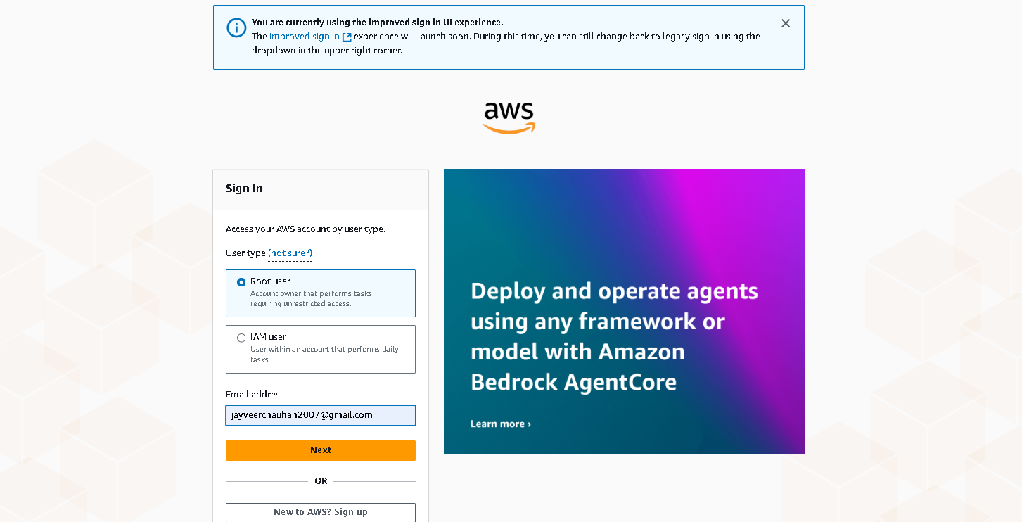

Step 1

Step 2

Step 3

Step 4

Step 5

Step 7

Step 10

Step 11

